

**School of Information Technology**

Course : Diploma in Business Informatics

Subject : ITP282 - Enterprise Application Development & Project

AY / Sem : 2018 S2

**Lab 3c: Website Design - Bootstrap**

**OBJECTIVES:**

At the end of this practical, the student should be able to:

1. To build a standard look and feel as well as responsive website
2. To implement bootstrap using CSS and JQuery

**Exercise 1: Create a website with Bootstrap using Empty Web Site in Visual Studio 2015**

1. Launch **Visual Studio 2015**.
2. Create a new**ASP.NET Empty Web Application**.

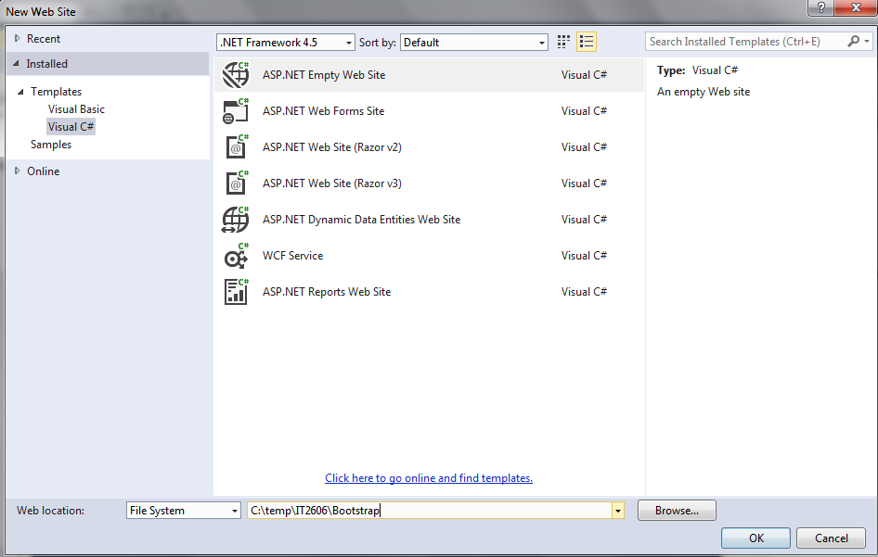

1. In the newly created website, create a folder named **Scripts** to store the java script and jQuery files.
2. Create another folder named **Content** (with a subfolder **css**) to store the css files.

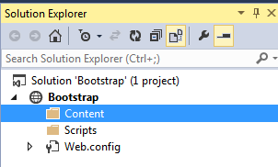

1. Bootstrap needs jQuery. Refer to resource file. Copy all .js files into Scripts folder in website.

*Note: The latest version of jQuery can be downloaded from* [*http://jquery.com/download/*](http://jquery.com/download/)*.*

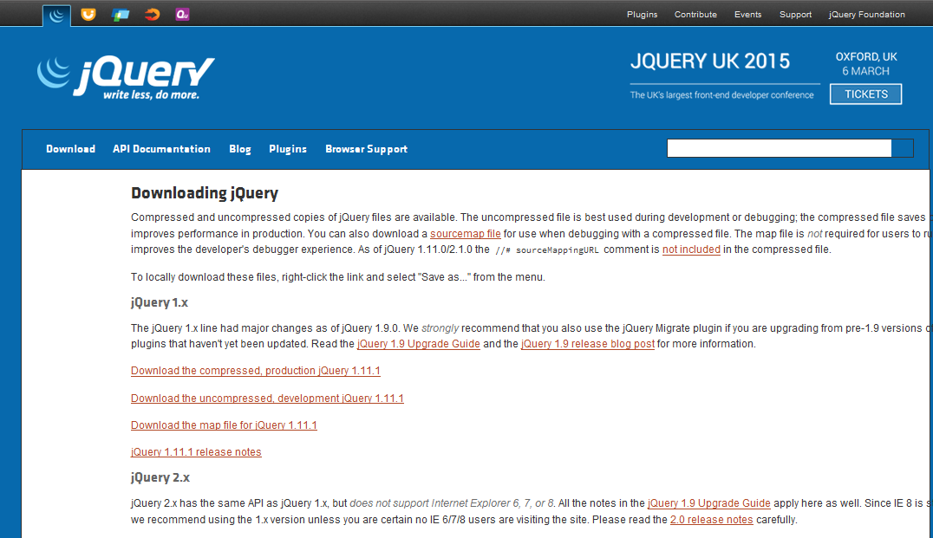

1. Copy the all the bootstrap css files in the resource file and place them inside the **Content/css** folder of the website.

*Note: The latest version of Bootstrap can be downloaded from http://getbootstrap.com/.*

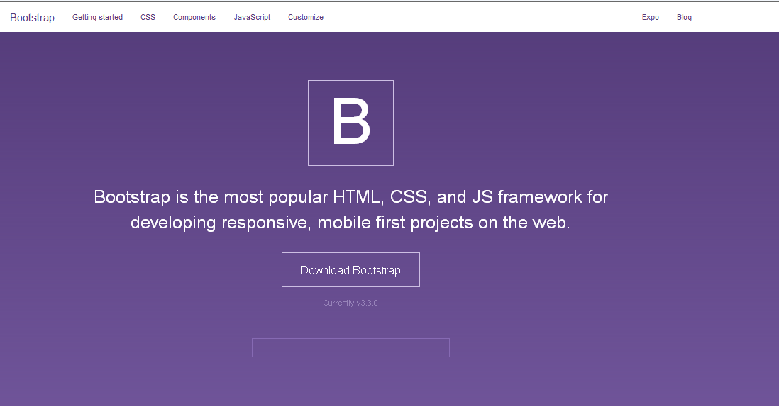

1. After including the files, the solution explorer looks like this.

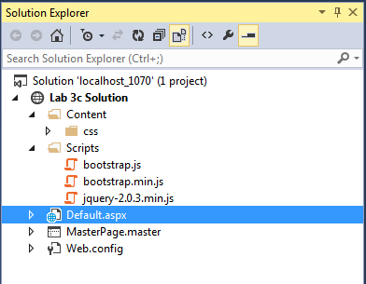

1. **Create** a master page for the project and re-name it if needed. For creating a master page,**right-click** the project in the solution explorer, select **Add**, select **New Item…** and create new Master Page.
2. Remove the **<form>** tag set from the master page.
3. Add the following navigation bar (**navbar**) section into the section below the start of the **<Body>** tag. Refer to resource file (Navigation Bar.txt)
4. In the **<div>** tag surrounding the <asp:ContentPlaceHolder> add the class **class=”container”**.

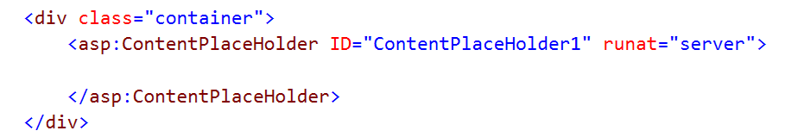

1. Just **above the end of the body** tag, add the **jQuery** file and the **bootstrap.min.js** file using the **script tag** with **src** attribute. Make sure to add jQuery file above the bootstrap file.
2. The master page is now ready and looks like this:

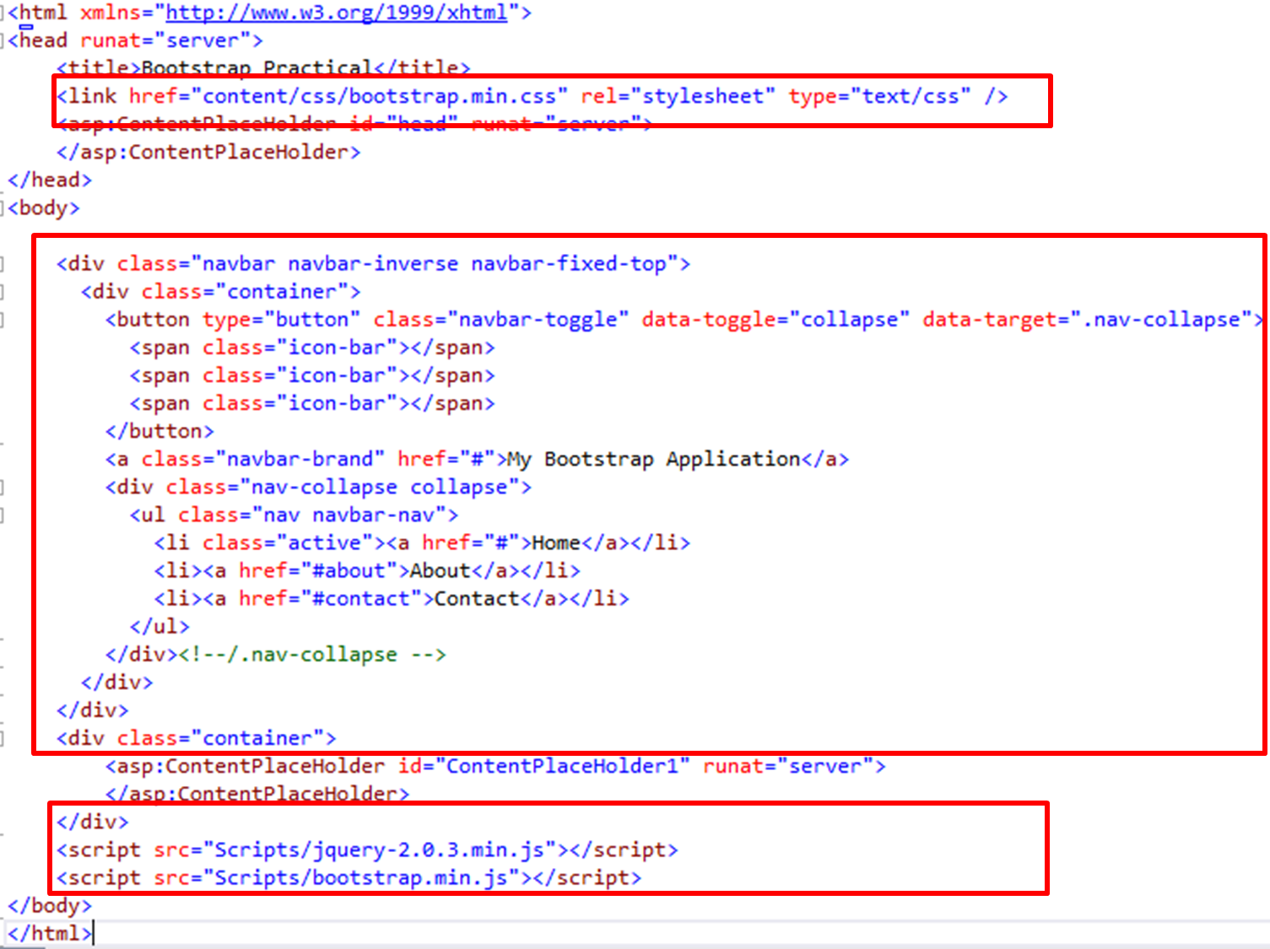

1. Create a default page. For creating Default.aspx page, right clicking the project, select Add, select New Item… and select **Web Form Using Master Page**. In the Master Page Selection screen select the new master page you have created earlier.

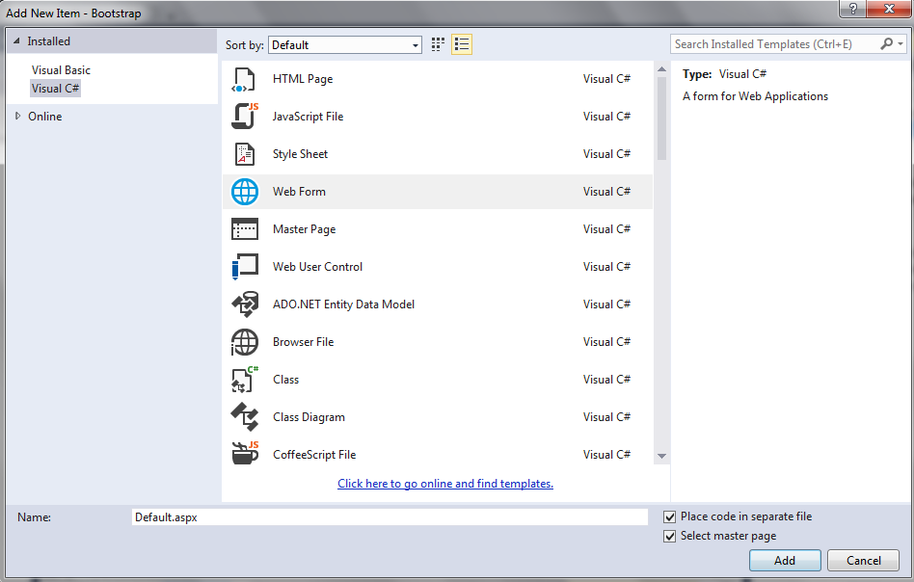

1. Edit the **Default.aspx** page and write something inside the **ContentPlaceHolder1** content section.
2. Now your solution is ready to be built.
3. Build the ASP.NET Web Forms solution, and view the Default.aspx page using either Firefox or Google Chrome. Microsoft IE may not be able to render the page properly.

*note: Alternatively, to simulate the viewing of responsive website in mobile gadgets can be carried out using mobile emulator (eg: http://www.asp.net/mobile/device-simulators).*

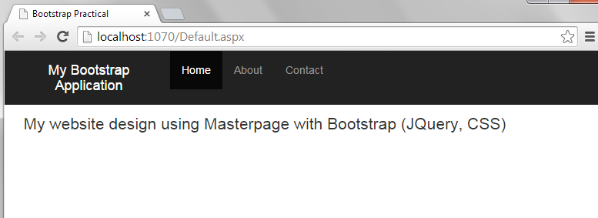

1. This bootstrap User Interface layout is responsive in nature. This is, when you open this UI in small screens like smart phones or tablets, the menu and content rearrange itself to fit the screen. You can check this by re-sizing the browser screen in PC.

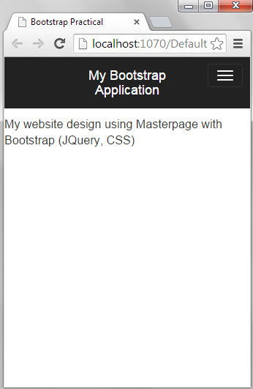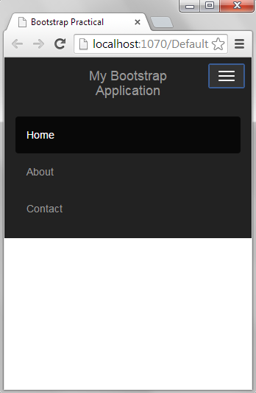

**Exercise 2: Create a website with Bootstrap using Web Forms Site in Visual Studio 2015**

1. Create a complete website using ASP.NET Web Forms Site option.

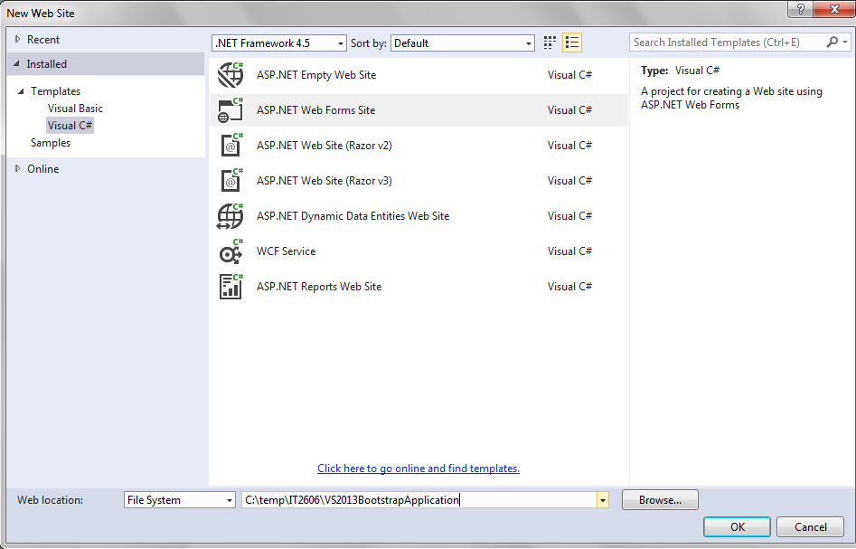

1. The newly created full website will be equipped with CSS and JQuery for bootstrap.

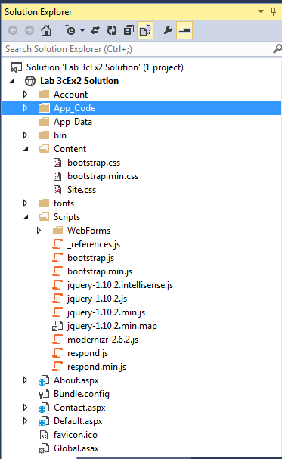

Note the version of Bootstrap (css, js) is in version 3.0.0 and JQuery is in version 1.10.2. The latest version for both (can be downloaded from respective website) is in version 3.3.0 and 2.1.1.

1. View Default.aspx page in browser (Google Chrome or Firefox).

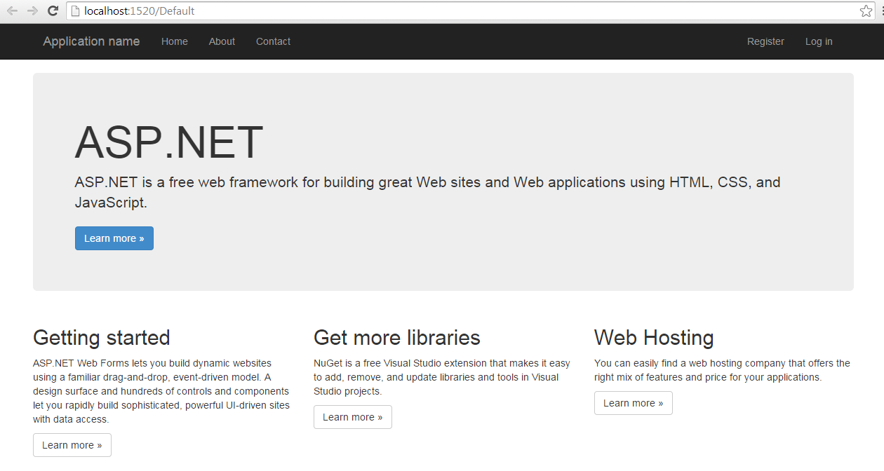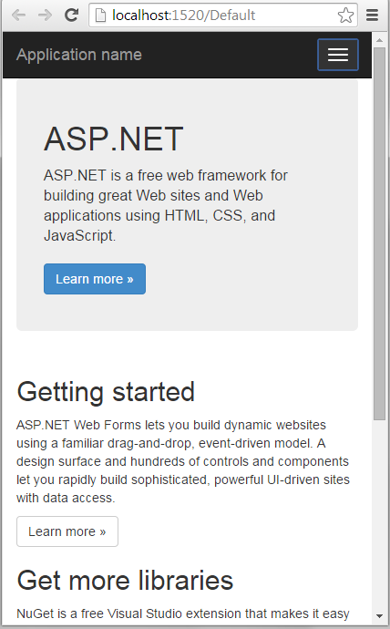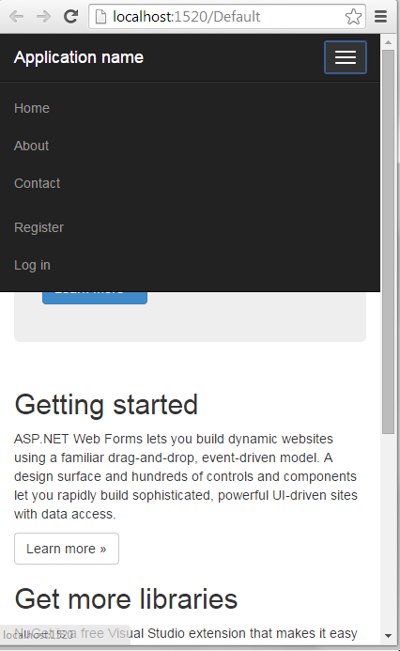

***========== End ==========***